TASK 1: Calculator

CODE:

import java.util.Scanner;

public class calculator {

public static void main(String[] args) {

Scanner scanner = new Scanner(System.in);

boolean calculation = true;

//using while loop so the user can attempt multiple calculations

while(calculation){

// Input two numbers

System.out.print("Enter first number: ");

double num1 = scanner.nextDouble();

System.out.print("Enter second number: ");

double num2 = scanner.nextDouble();

// Input operation

System.out.print("Choose an operation (+, -, *, /): ");

char operator = scanner.next().charAt(0);

double result;

// Switch case for operations

switch (operator) {

case '+':

result = num1 + num2;

System.out.println("Result: " + result);

break;

case '-':

result = num1 - num2;

System.out.println("Result: " + result);

break;

case '*':

result = num1 * num2;

System.out.println("Result: " + result);

break;

case '/':

if (num2 != 0) {

result = num1 / num2;

System.out.println("Result: " + result);

} else {

System.out.println("0 division will not occur");

}

break;

default:

System.out.println("Invalid operator!");

continue;

}

System.out.print("do you want perform calculation? (yes/no):");

String choice = scanner.next();

if(!choice.equalsIgnoreCase("yes")){

calculation=false;

}

}

System.out.println("End of Calculation");

scanner.close();

}

}

**Output:**

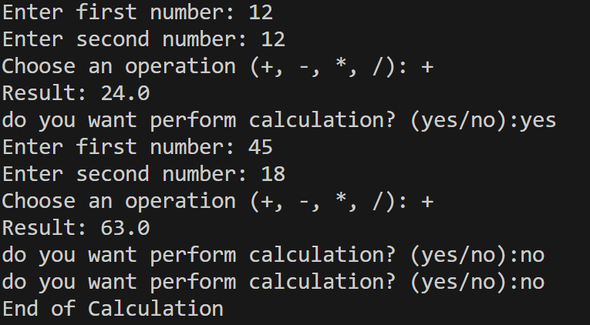**s**